Bansilal Ramnath Agarwal Charitable Trust’s

Vishwakarma Institute of Technology, Pune-37

Department Of Artificial Intelligence and Data Science

Lab Manual

**COMPUTER NETWORK**

# **AI2003**

## Class: - SY BTECH Branch: - AIDS

Prepared By: - Prof. G. S. UBALE Year: -2023-24

### Examinations: - Lab Assessment (Continuous)

Required H/W and S/W: - Windows/Linux, C, C++

**Experiment Number: 01**

**TITLE: Study and implement various networking commands on terminal.**

**OBJECTIVES:**

1. To understand different networking command.
2. To understand how to execute the networking commands.

**PRE REQUISITE: -** Basic Programming concepts using C/C++

Networking Commands

Networking commands are specific commands that can be executed in a command-line interface or terminal to manage and troubleshoot network-related tasks. Here are some commonly used networking commands:

**1] ping :**

Tests connectivity between your system and a target by sending ICMP echo requests and measuring response time.

Syntax : ping hostname/IP address

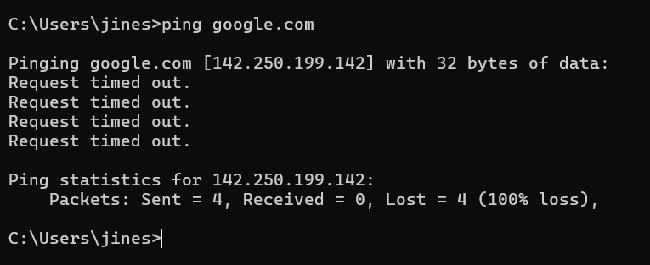

**2] tracert :**

Traces the path packets take to reach a destination, listing all intermediate routers.

Syntax : tracert hostname/IP address

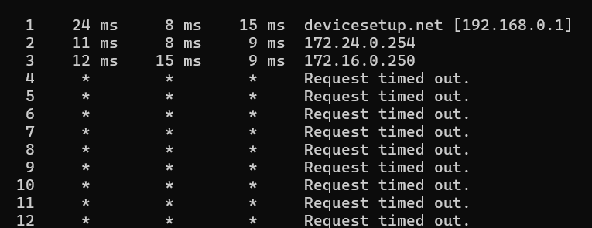

3] **ipconfig:**

Displays or configures network interface information, like IP address and subnet mask.

Syntax : ipconfig

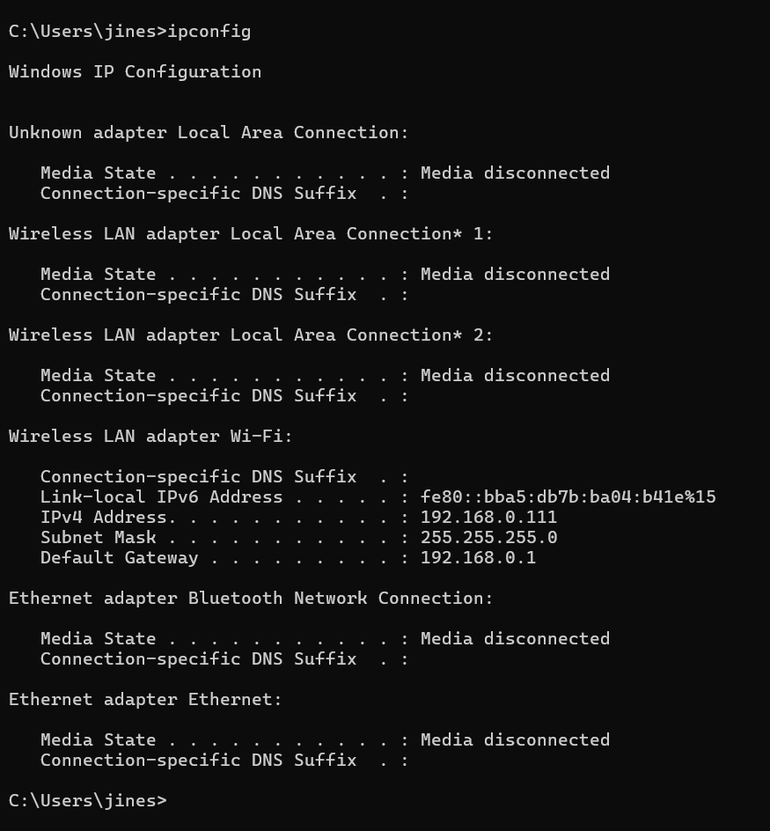

4] **inslookup :**

Queries DNS servers to resolve domain names to IP addresses or vice versa.

plaintext

Syntax : nslookup domain name/IP address

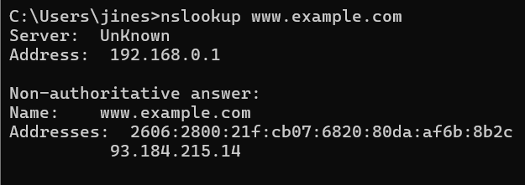

5] **nestat:**

Shows active network connections and listening ports.

Syntax : netstat -an

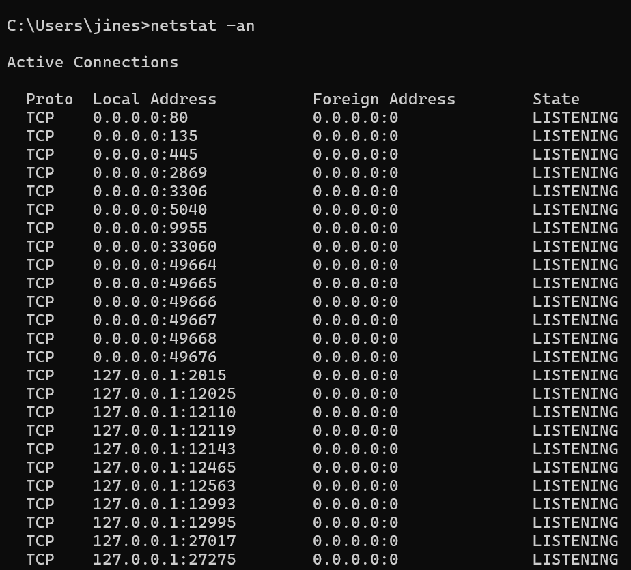

6] **curl:**

Transfers data from or to a server using URL syntax.

Syntax : curl http://example.com

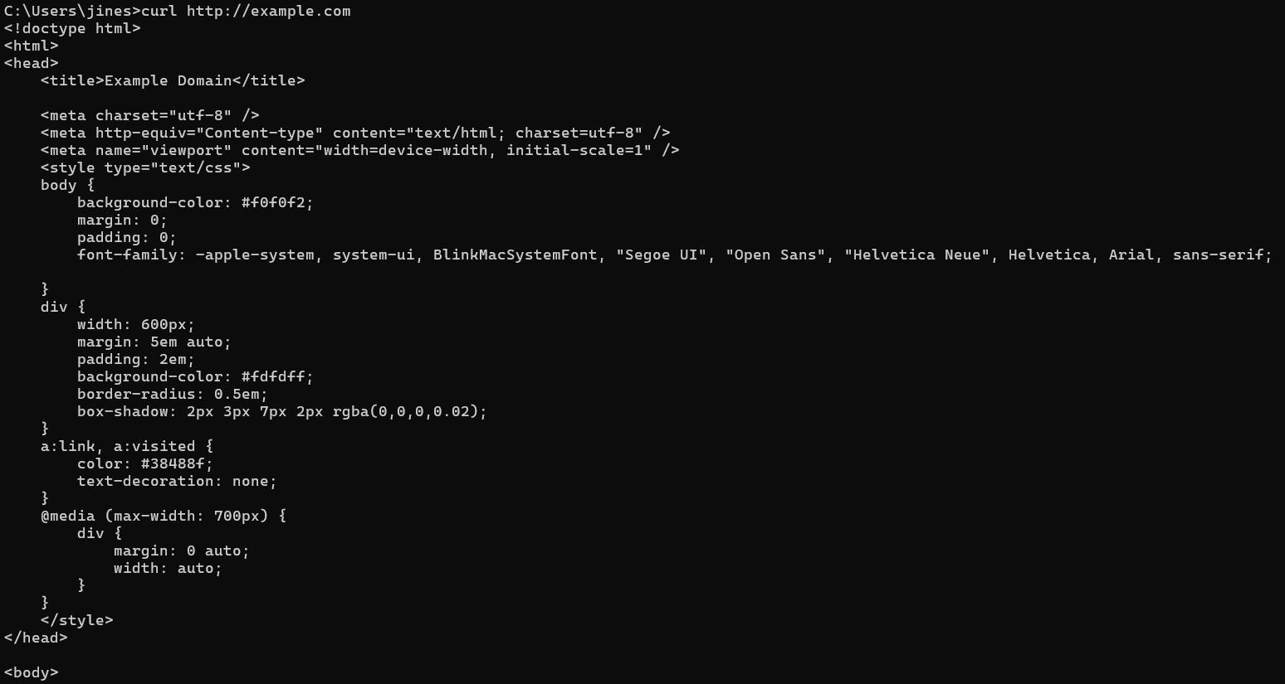

7] **hostname:**

Displays or sets the system's hostname.

Syntax : hostname

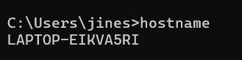

8] **arp:**

Displays or modifies the ARP table.

Syntax : arp

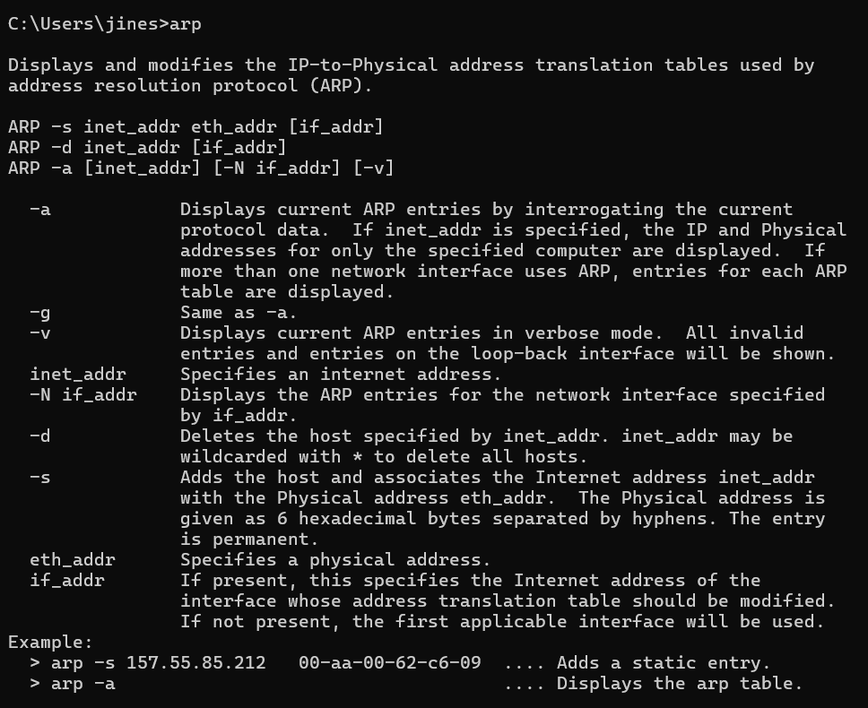

9] **route:**

Displays or modifies the routing table.

Syntax : route

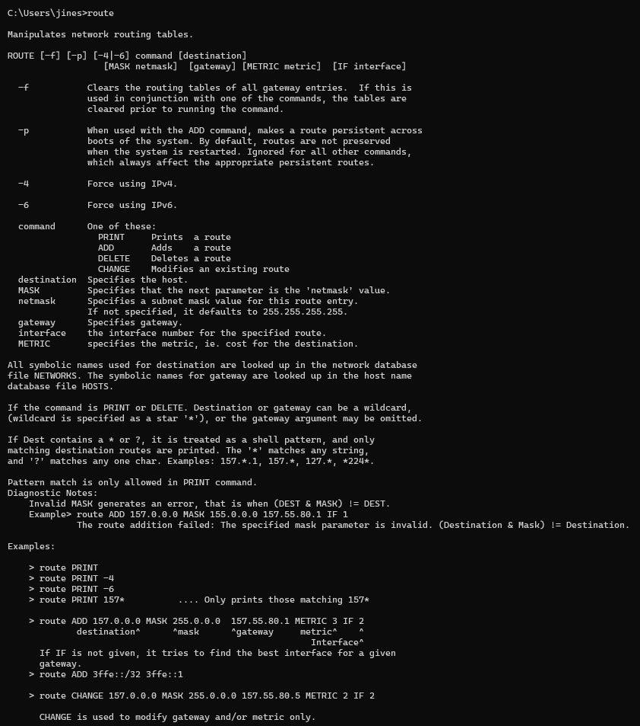

10] **nbstat:**

It displays the local NetBIOS name cache and names resolved via broadcast.

Syntax : nbtstat -r

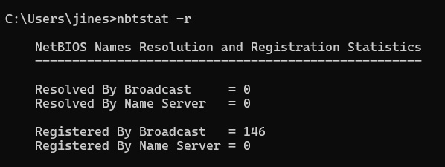

11] **getmac:**

Displays the Media Access Control (MAC) address of all network adapters connected to your system.

Syntax : getmac

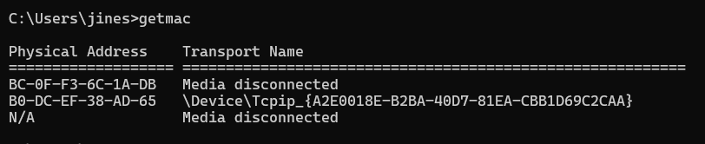

## 12] **Test-Connection :**

Similar to ping, it sends ICMP packets to test network connectivity to a host.

Syntax : Test-Connection google.com

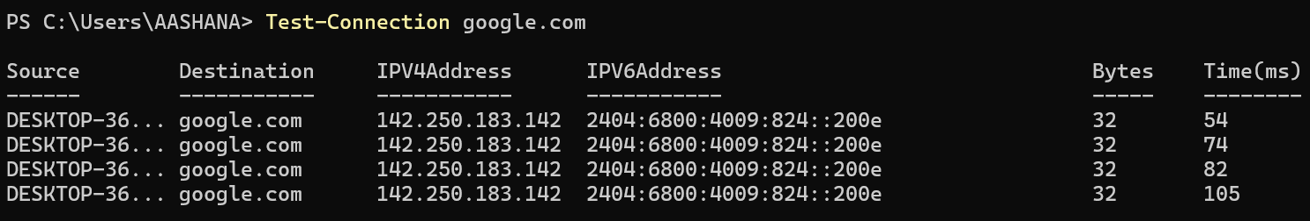

13] **Net View:**

Displays a list of shared resources (e.g., shared folders or printers) on a specified network computer.

Syntax : net view \\<computer_name>

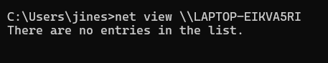

14] **Net Use:**

Connects or disconnects from a shared resource on a network.

Syntax : net use Z: \\<server_name>\share

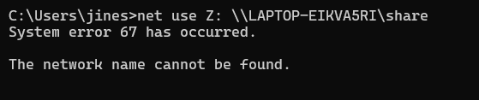

## 15] **telnet:**

Connects to a remote host via the Telnet protocol.

Syntax : telnet example.com 23



## Windows and Linux Networking Commands:

|  |  |  |  |  |  |
| --- | --- | --- | --- | --- | --- |
| | **Windows Command** |  | | --- | --- | | |  | **Linux Equivalent** | | --- | --- | |
| |  |  | | --- | --- | | ping |  | | |  |  | | --- | --- | |  | ping | |
| |  |  | | --- | --- | | tracert |  | | |  |  | | --- | --- | |  | traceroute | |
| |  |  | | --- | --- | | **nslookup** |  | | |  |  | | --- | --- | |  | nslookup / dig | |
| |  |  | | --- | --- | | ipconfig |  | | |  |  | | --- | --- | |  | ifconfig / ip addr | |
| |  |  | | --- | --- | | netstat |  | | |  |  | | --- | --- | |  | netstat / ss | |
| |  |  | | --- | --- | | curl |  | | |  |  | | --- | --- | |  | curl | |
| |  |  | | --- | --- | | hostname |  | | |  |  | | --- | --- | |  | hostname | |
| |  |  | | --- | --- | | **arp** |  | | |  |  | | --- | --- | |  | arp / ip neigh | |
| |  |  | | --- | --- | | **rout**e |  | | |  |  | | --- | --- | |  | route / ip route | |
| |  |  | | --- | --- | | **nbtstat** |  | | |  |  | | --- | --- | |  | smbclient / nmblookup | |
| |  |  | | --- | --- | | **getmac** |  | | |  |  | | --- | --- | |  | ip link / ifconfig | |
| |  |  | | --- | --- | | Test-Connection |  | | |  |  | | --- | --- | |  | ping / fping | |
| |  |  | | --- | --- | | net view |  | | |  |  | | --- | --- | |  | smbclient / nmblookup | |
| |  |  | | --- | --- | | net use |  | | |  |  | | --- | --- | |  | mount | |
| |  |  | | --- | --- | | telnet |  | | |  |  | | --- | --- | |  | telnet | |